Experiment No.: 7


Title: Usability Testing
Batch: B–1 Roll No.: 16010422234 Experiment No.: 7
__________________________________________________________________________

Aim: To perform usability testing using any open source tool.
__________________________________________________________________________

Resources needed: Internet, Chrome Browser
__________________________________________________________________________

Theory:

Usability testing, also known as User Experience (UX) testing, is a testing method for measuring how easy and user-friendly a software application is. A small set of target end-users, use software applications to expose usability defects. Usability testing mainly focuses on the user's ease of using application, flexibility of application to handle controls and ability of application to meet its objectives. This testing is recommended during the initial design phase of SDLC, which gives more visibility on the expectations of the users.

Users are asked to complete tasks, typically while they are being observed by a researcher, to see where they encounter problems and experience confusion. If more people encounter similar problems, recommendations will be made to overcome these usability issues.


“Usability engineering” is the process of identifying users’ needs to ensure a product can achieve specific goals effectively and efficiently, which results in overall satisfaction and success. To mitigate user issues and ensure your product is working for its intended audience, you need to venture into the world of usability engineering.

Usability is a combination of many factors and theories, but all can be targeted to achieve the goals below:
- Intuitive Design and/or user interface
- Ease of learning
- Efficiency of use
- Memorability
- Error prevention
- User Satisfaction

It is important for any web designer to design functional sites that can easily generate interest and online traffic among the internet users. The user interface design of your site plays a vital role in bringing high volume web traffic to it. Therefore, web designers should give due importance to the user interface of the site which is being designed by them. In the present era, there is an explosive growth in e-commerce with billions of dollars worth of sales taking place each year. Today, thousands of businesses are completely dependent on the internet for their success.

The Internet has emerged as a one-stop source of entertainment, information, social interaction and commerce. For success in any online business, a user friendly website is a must as it will provide enhanced user experience to the online visitors. Any site that is too complex and difficult will definitely push away online traffic. The use of effective and simple user interface design will be of immense help in achieving the objectives of a website. A good user interface not only increases the site usability but also leads to the smooth completion of any task at hand thereby making everything enjoyable and flexible as per the requirements of users.

Following are the tools which are useful in usability testing:
- Lighthouse
- Website Grader
- Google PageSpeed Tools
- GTmetrix


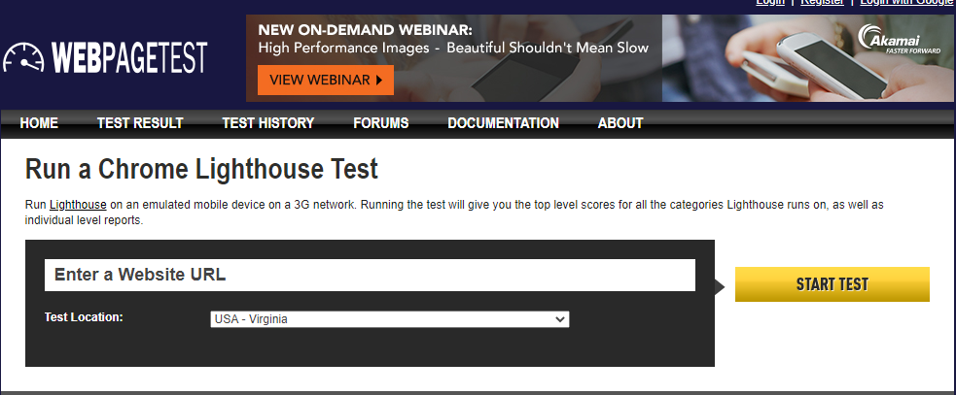
Webpagetest: Lighthouse
__________________________________________________________________________

Procedure:
- Explore any one tool for usability testing.

The open-source tool selected and utilized for this usability testing experiment is Lighthouse. Lighthouse is an automated auditing tool developed by Google that assesses the quality of web pages across five key categories: Performance, Accessibility, Best Practices, Search Engine Optimization (SEO), and Progressive Web App (PWA) capabilities. It provides actionable feedback to ensure web products are fast, accessible, and follow modern web standards.
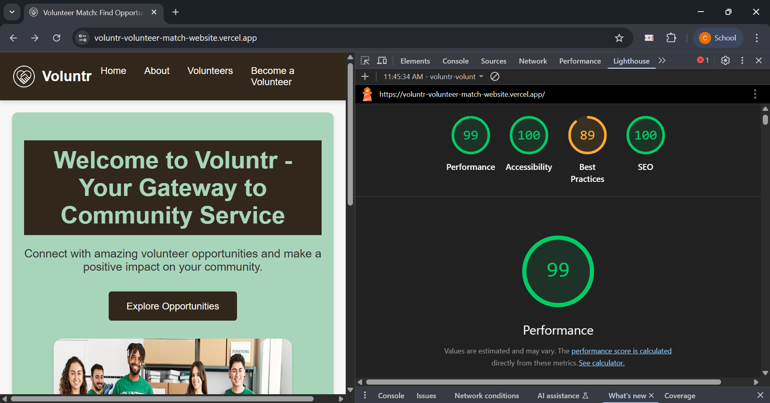

- Perform usability testing of any website and generate the report for the same.

Website Tested: https://voluntr-volunteer-match-website.vercel.app/

The Lighthouse audit was conducted using the Chromium DevTools under a desktop emulation and custom throttling.

- Analyze and summarize reports for quality and performance of web pages.

Performance Analysis (Score: 99/100)
The website demonstrates exceptional loading speed and responsiveness. Key performance metrics (Core Web Vitals) are as follows:
- First Contentful Paint (FCP): 0.2 s.
- Largest Contentful Paint (LCP): 0.8 s. The LCP element is the main heading: "Welcome to Voluntr - Your Gateway to Community Service".
- Total Blocking Time (TBT): 0 ms.
- Cumulative Layout Shift (CLS): 0.
These metrics indicate that content loads nearly instantly, and the user interface is completely stable with no input delay, providing a superior user experience.

Accessibility Analysis (Score: 100/100)
The perfect score confirms that the site adheres to all automated accessibility checks, promoting inclusivity.
- Color Contrast: Background and foreground colors have a sufficient contrast ratio.
- Semantic Structure: Buttons have accessible names , image elements have [alt] attributes , and heading elements appear in sequentially-descending order.
- Viewport: The viewport meta tag is correctly configured, which is crucial for mobile optimization and preventing input delay.

Best Practices Analysis (Score: 89/100)
The minor drop in score is attributed to critical security and maintenance issues:
- Security Vulnerabilities: The audit failed checks for effective security policies, specifically noting "No CSP found in enforcement mode", "No COOP header found", and "No frame control policy found" (for X-Frame-Options/CSP). These missing headers expose the application to high-severity attacks like XSS and clickjacking.
- Image Sizing: A significant finding under best practices is that an image file (logo.89ffbec....jpg) is larger than its displayed dimensions (606x605 vs. 60x60), wasting bandwidth.
- Browser Errors: Unresolved problems were logged to the console, including a syntax error in the manifest.json file.

SEO Analysis (Score: 100/100)
The site is highly optimized for search engine discoverability. Key factors include:
- The page is not blocked from indexing.
- The document has a <title> element and a meta description.
- Links are crawlable and have descriptive text.

- Suggest improvements based on your analysis.

Based on the audit, the primary focus areas should be security hardening and content optimization:
- Mandatory Security Hardening: Immediately implement the required security headers, specifically:
  - Content Security Policy (CSP): To prevent Cross-Site Scripting (XSS) attacks.
  - Cross-Origin-Opener-Policy (COOP): To ensure proper origin isolation.
  - X-Frame-Options (XFO) or CSP frame-ancestors: To mitigate clickjacking.
- Optimize Image Assets: Rectify the inefficient image delivery flagged as a major saving opportunity (Est savings of 580 KiB).
  - Serve images, particularly the logo, at their actual display size to reduce file size.
  - Consider using modern image formats (WebP/AVIF) and applying efficient cache lifetimes to reduce repeat-visit load times.
- Third-Party Code Management: Evaluate the necessity and loading strategy for the Google Tag Manager script, as it is a major contributor to main-thread activity and transfer size. Consider lazy-loading or deferring its execution.
- Resolve Maintenance Issues: Fix the "Syntax error" in the manifest.json file to address logged browser errors.
__________________________________________________________________________

Questions:

- Describe usability and accessibility testing. Explain any five test cases/scenarios for testing usability and accessibility of a web application.

Ans: Usability Testing: Usability testing (also known as User Experience (UX) testing) is a testing method that measures how easy, effective, and user-friendly a software application is to use. It involves a small set of target end-users attempting to complete specific tasks while a researcher observes them to identify usability defects. The core focus is on the user's ease of using the application, flexibility to handle controls, and ability to meet its objectives. Usability aims for: Intuitive Design, Ease of Learning, Efficiency of Use, Memorability, Error Prevention, and User Satisfaction.

Accessibility Testing: Accessibility testing is focused on ensuring that a web application can be used effectively by people with disabilities (such as visual, auditory, cognitive, or motor impairments). The goal is to verify that all users can perceive, operate, and understand the content, typically by adhering to standards like the Web Content Accessibility Guidelines (WCAG).

Five Test Cases/Scenarios for Usability and Accessibility:

Type | Test Case/Scenario | Focus
Usability | Scenario 1: New User Registration and Login | Ease of Learning & Efficiency
 | Goal: A new user successfully creates an account and logs in. | Test Steps: Verify that form fields are clearly labeled, error messages are helpful, and the navigation flow is direct.
Usability | Scenario 2: Primary Goal Completion (e.g., Purchasing an item) | Efficiency of Use & Task Completion
 | Goal: A user navigates to the core function of the site and successfully completes a transaction. | Test Steps: Measure the number of clicks and time required. Ensure clear feedback is provided upon task completion.
Accessibility | Scenario 3: Keyboard-Only Navigation | Motor Impairment & Operability
 | Goal: A user navigates and interacts with all elements (links, buttons, forms) using only the Tab key and Enter/Space. | Test Steps: Ensure a highly visible focus indicator is present and the tab order is logical (matches the visual layout).
Accessibility | Scenario 4: Screen Reader Compatibility for Images | Visual Impairment & Perceivability
 | Goal: A user using a screen reader attempts to understand the images and non-text content. | Test Steps: Verify that all informative image elements have descriptive alt attributes and decorative images have null or empty alt text.
Usability | Scenario 5: Error Handling and Recovery | Error Prevention & Memorability
 | Goal: A user intentionally makes a mistake in a form (e.g., wrong password format or missing required field). | Test Steps: Assess if the error message is clear, non-technical, and guides the user on how to fix the error, and if input data is retained.

- What are the benefits of usability testing for website owners?

Ans: Usability testing is vital for website owners because it directly impacts business success, user satisfaction, and operational costs. The benefits include:
- Increased User Satisfaction and Retention: An easy-to-use website provides an enhanced user experience (UX), leading to greater satisfaction, reduced frustration, and increased loyalty among online visitors.
- Higher Conversion Rates: When a site is intuitive and efficient, users can complete desired tasks—like sign-ups, information retrieval, or purchases—with fewer roadblocks, directly translating to higher sales and goal completion.
- Reduced Development and Support Costs:
  - Early Defect Detection: Testing is recommended during the initial design phase of the SDLC, allowing developers to address user expectations and fix defects when they are cheapest to correct.
  - Lower Support Load: A user-friendly site results in fewer user errors and confusion, leading to fewer customer support inquiries and lower associated operational costs.
- Increased Online Traffic and Engagement: A functional, simple, and user-friendly website generates interest and encourages repeat visits, which is essential for success in any online business.
- Competitive Advantage: Websites that focus on a seamless and enjoyable user interface design stand out from competitors that are "too complex and difficult".
__________________________________________________________________________

Outcomes: CO3 – Apply recent automation tools for testing software.
__________________________________________________________________________

Conclusion: (Conclusion to be based on outcomes)
The usability testing conducted on the Voluntr website using the open-source Lighthouse tool successfully achieved the aim of the experiment. The site demonstrated Excellent Usability and Performance with high scores across most categories: Performance (99/100), Accessibility (100/100), Best Practices (89/100), and SEO (100/100). Specifically, the site exhibited extremely fast loading times, evidenced by key metrics like First Contentful Paint (0.2 s) and Largest Contentful Paint (0.8 s), contributing directly to high user satisfaction and efficiency of use. The Accessibility score of 100 confirms the site's strong adherence to inclusive design principles, while the perfect SEO score ensures high discoverability. However, the analysis of the Best Practices (89/100) section identified critical areas for improvement related to security headers (CSP, COOP, XFO) and image optimization. The experiment demonstrates that continuous usability and performance auditing is essential for maintaining a high-quality, secure, and performant user experience, even for applications that are already highly optimized.
__________________________________________________________________________

Grade: AA / AB / BB / BC / CC / CD / DD

Signature of faculty in-charge with date
__________________________________________________________________________

References:
Books/ Journals/ Websites:
- https://developers.google.com/web/tools/lighthouse/
- https://developers.google.com/speed/pagespeed/insights/
- https://www.webpagetest.org/lighthouse
- https://www.guru99.com/usability-testing-tutorial.html
- https://gtmetrix.com/
__________________________________________________________________________

